**Experiment 23**

**Lab Book:**

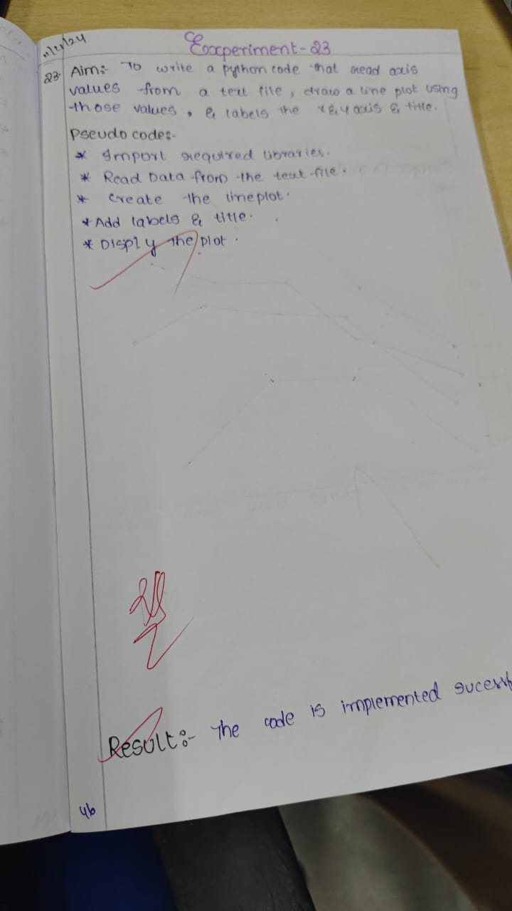

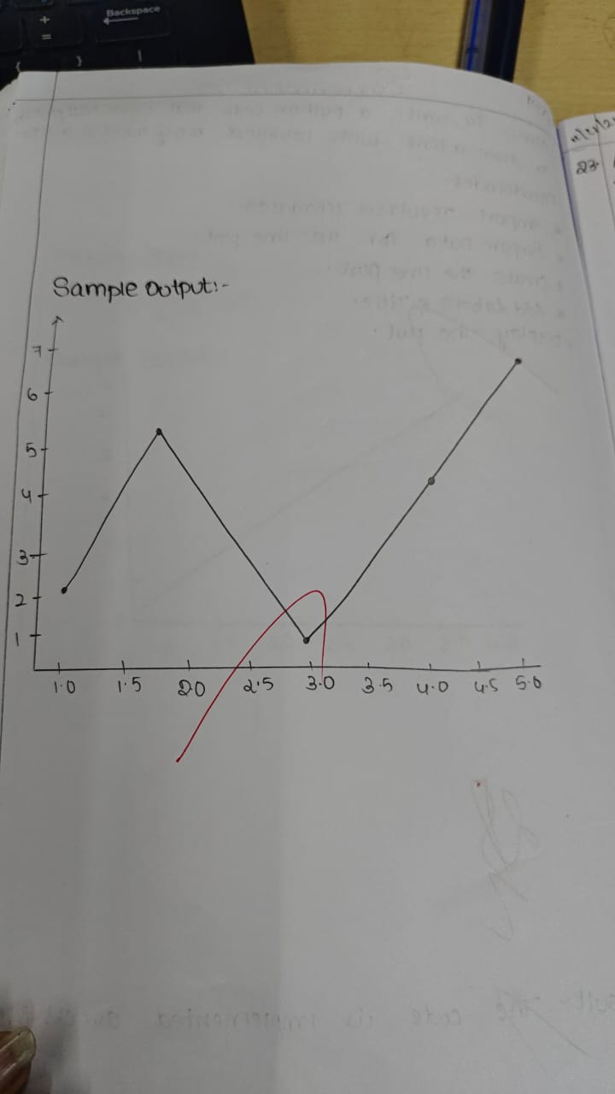

**Code:**

import matplotlib.pyplot as plt

x = [1, 2, 3, 4, 5]

y = [2, 4, 1, 3, 5]

plt.plot(x, y, marker='o', color='green', label='Data Line')

plt.xlabel('X Axis Label')

plt.ylabel('Y Axis Label')

plt.title('Line Plot from Direct Data')

plt.legend()

plt.show()

**Sample Output**

